**Use of Liquid Galaxy in Cinema** is quite easy and nominal but it would affect a lot of people. The Liquid Galaxy covers those small details that are required to make something perfect. Cinema theaters have been always a fun place since childhood for all of us. We always enjoyed eating popcorn at the intervals but didn’t like that huge queue. There are many uses of Liquid Galaxy in a Cinema Theater. Be it the booking queue or the advertisement banners. Liquid Galaxy provides easiness in reading and improves the audience reachability.

Here is a sample image of the movie advertisement banners in a Cinema Theater :

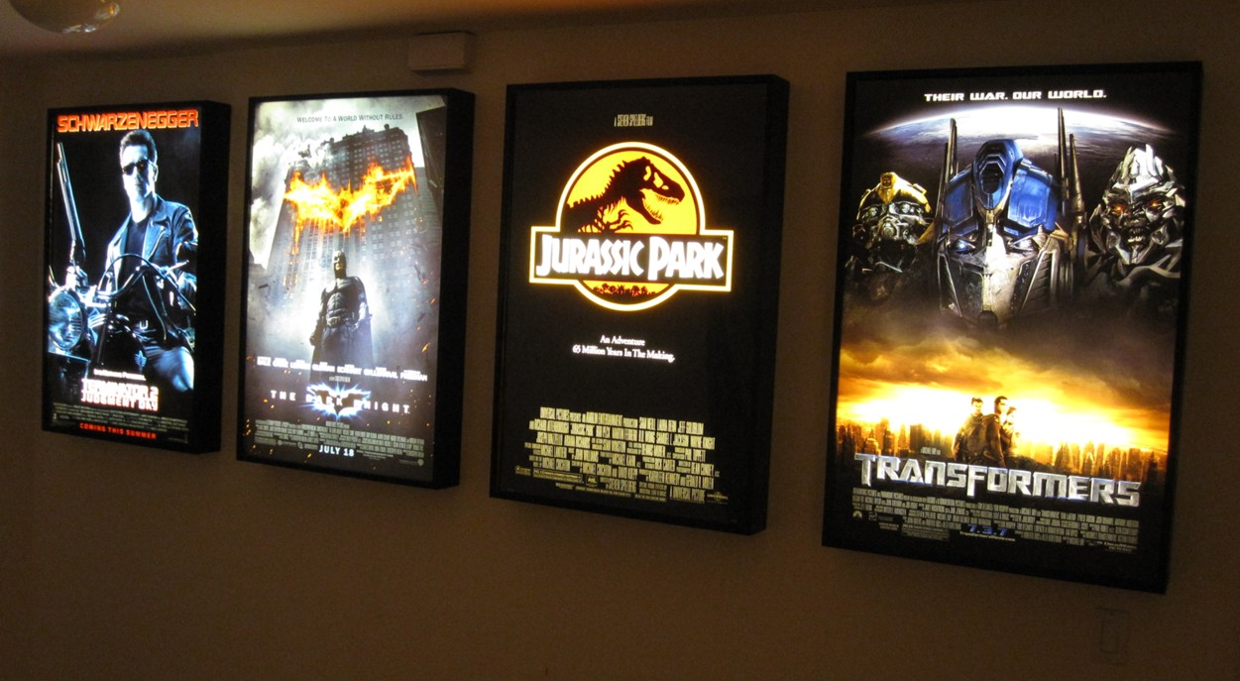

Now I’d like to list some use cases for the Liquid Galaxy :

**1) Using Liquid Galaxy to display trailer, previews and prices :** Liquid Galaxy can be used to display the Movie Trailer along with the Movie Previews and the Prices for various types of seating available. This is will enable better advertising as it will have dedicated displays for each movie.

Here is an illustration showing the setup :

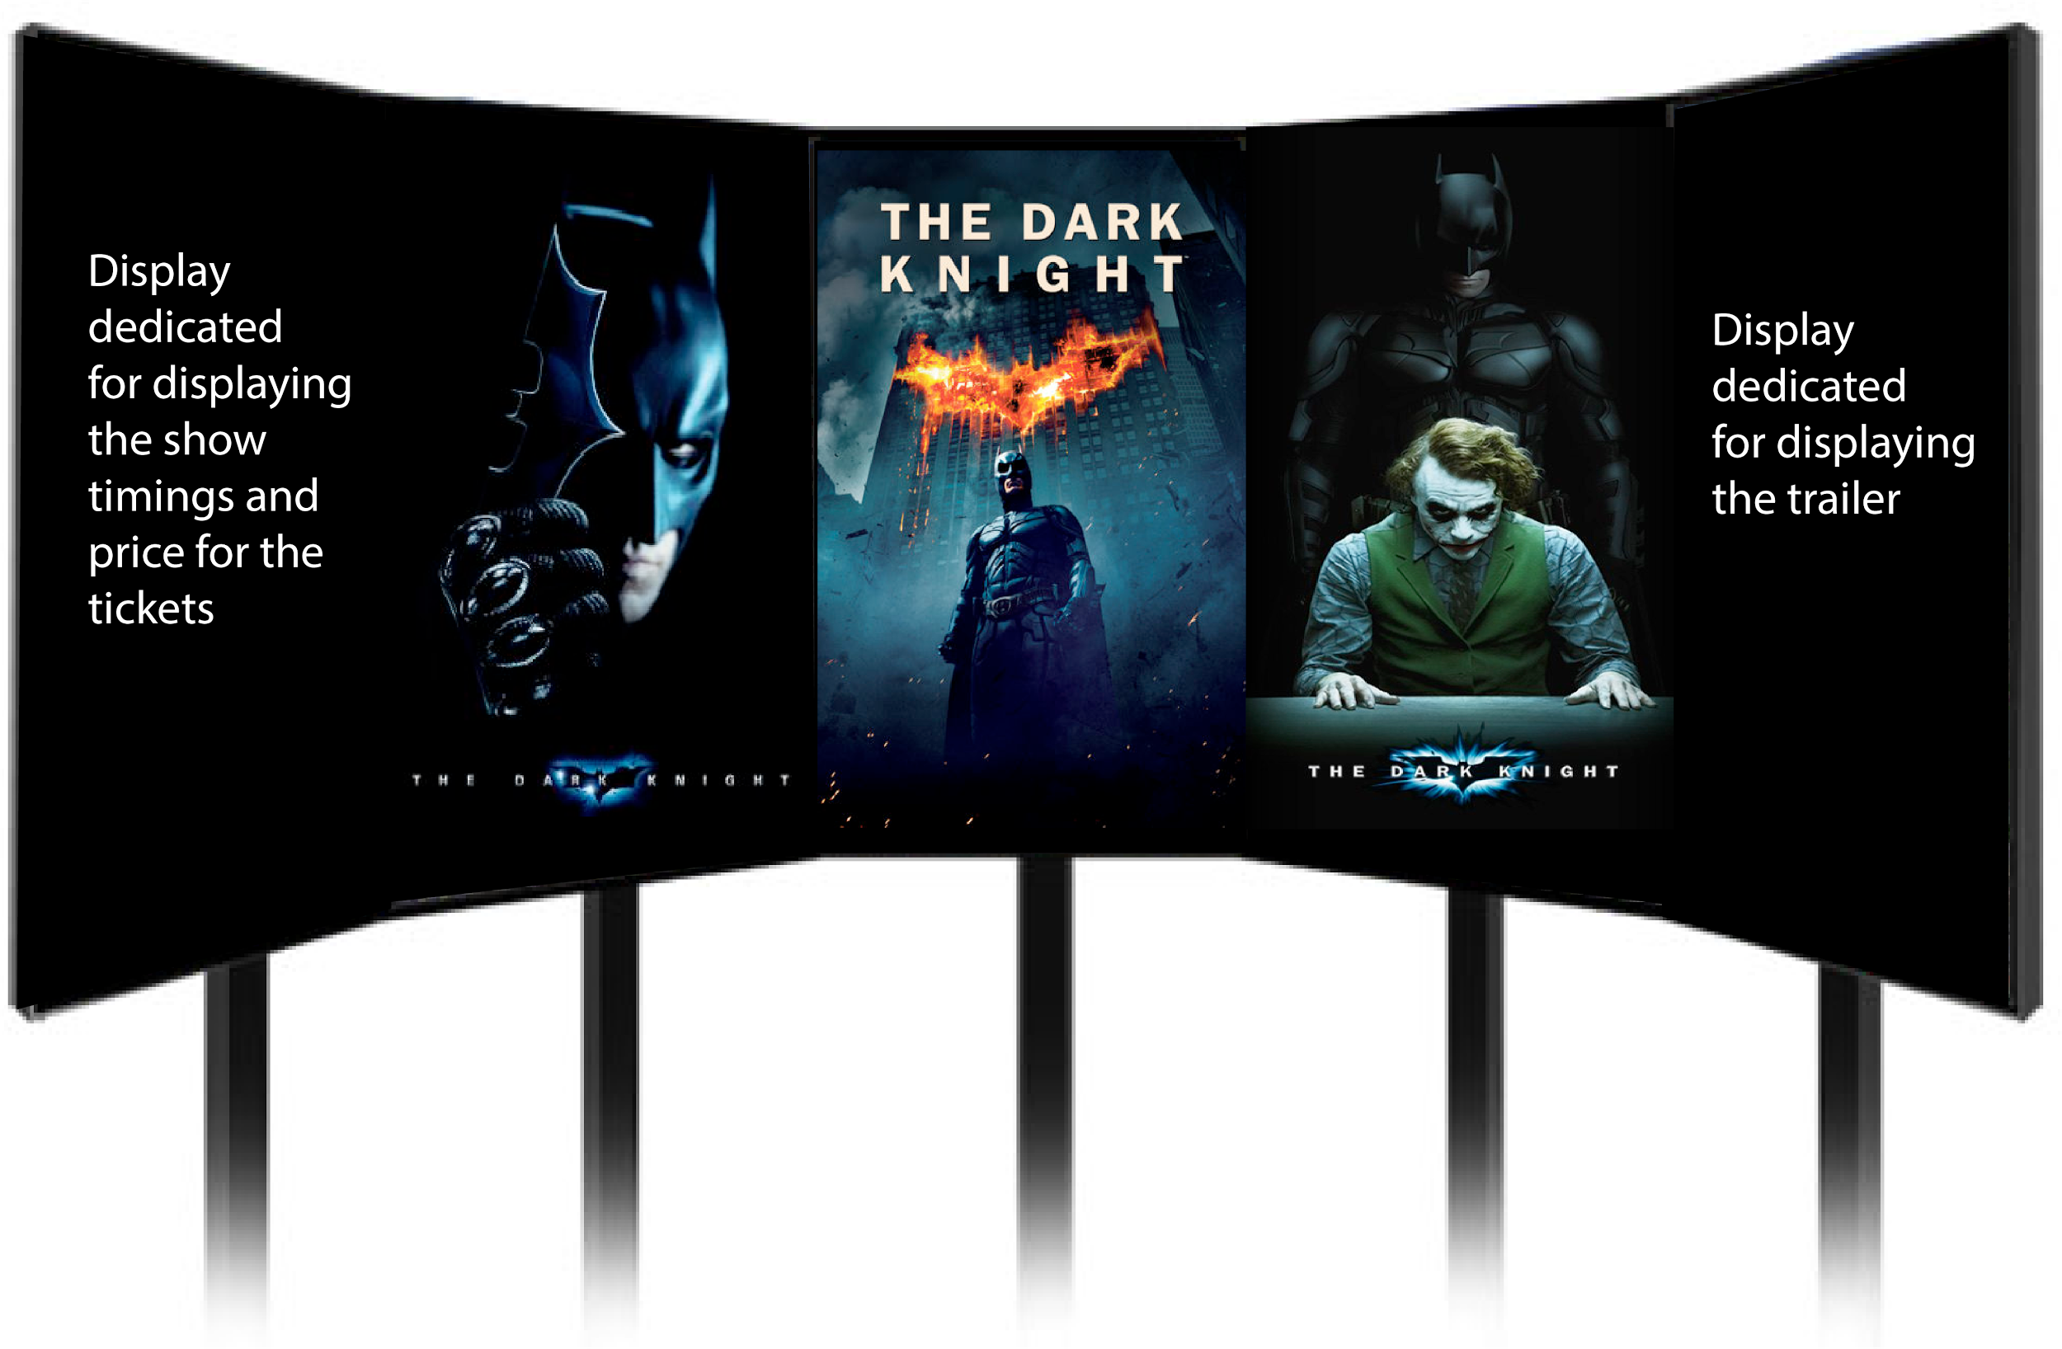

**2) Use of Liquid Galaxy to display the already filled seats and the available seating plans :** Liquid Galaxy can be used to display the number of available seats and the seating arrangement in the Cinema Hall.

Let’s say we go to the Cinema Booking Counter it happens that sometimes we don’t get out desired seats. So a Liquid Galaxy system can be dedicated to show the available seating plan before going to the booking counter. So that we are not dissatisfied with the alloted seats. So after standing in a large queue you get to know that you will be seated in a corner of the hall and rest of your family in the other corner won’t that be heartbreaking ? Here will be the Liquid Galaxy ‘The Saviour’ to safeguard you from such experience.

Here is an illustration of the setup :

